**CRM APPLICATION THAT HELPS TO BOOK A VISA SLOT**

**INTRODUCTION**

Overview:

A visa slot management project is a system that is used to track and manage the availability of visa slots, which are appointments that are required for certain visa applications. It might be used by a government agency or a visa processing center to schedule and manage appointments with applicants.

Purpose:

Saving the time of the customers who want to book it by using CRM application of booking a Visa slot. Wandering for booking the Visa slot and tracking can be reduced here. Reduce the paper filling as much the customer expecting. Ensuring the safety of the customers and panic of many verifications.

**PROBLEM DEFINITION AND DESIGN THINKING:**

Empathy map:

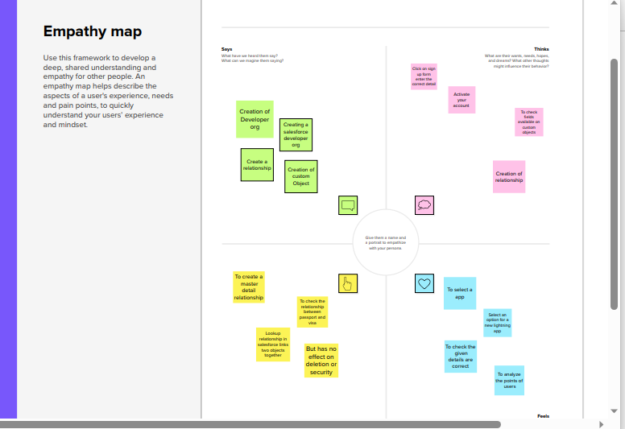

Ideation and Brainstorming map:

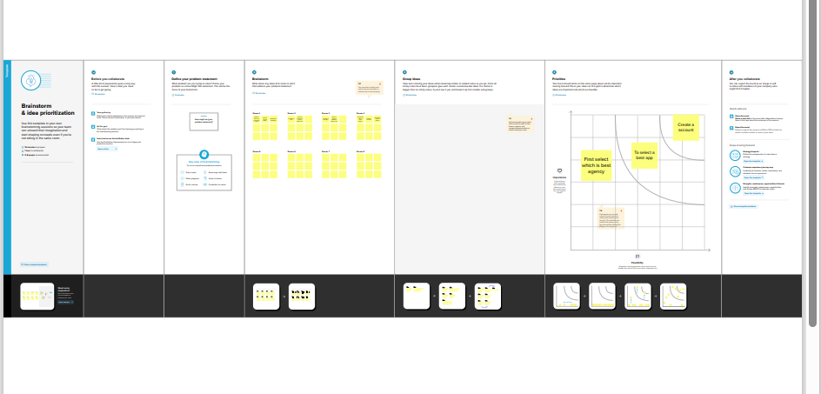

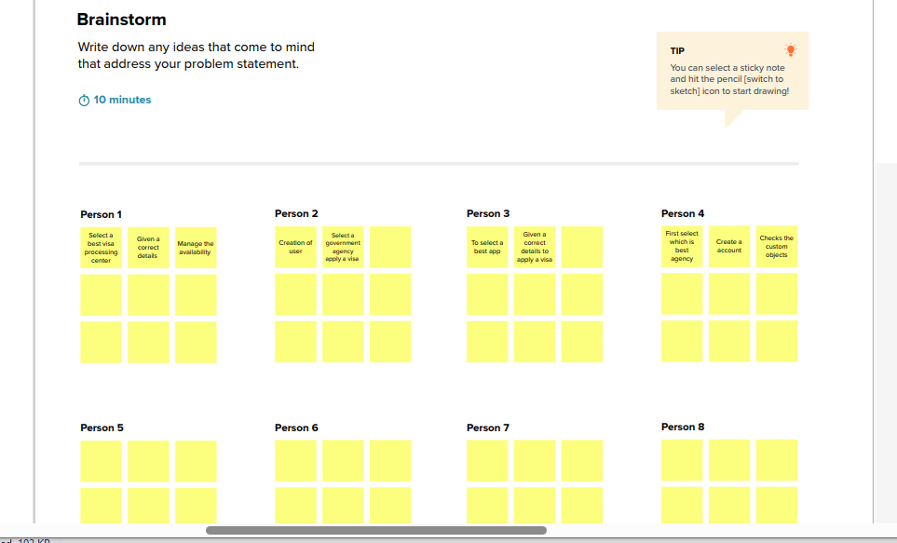

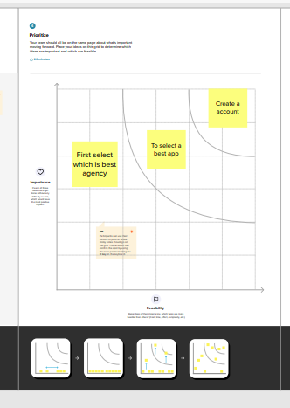

**ACTIVITY AND SCREENSHOTS**

1. Creation of Salesforce platform:

Go to Developer.salesforce.com and click on sign up. Enter our Detail as name, Email, Role, Company etc., Email is sent your mail id.

Go to the inbox of the email that you used while signing up. Click on the verify account to activate your account.

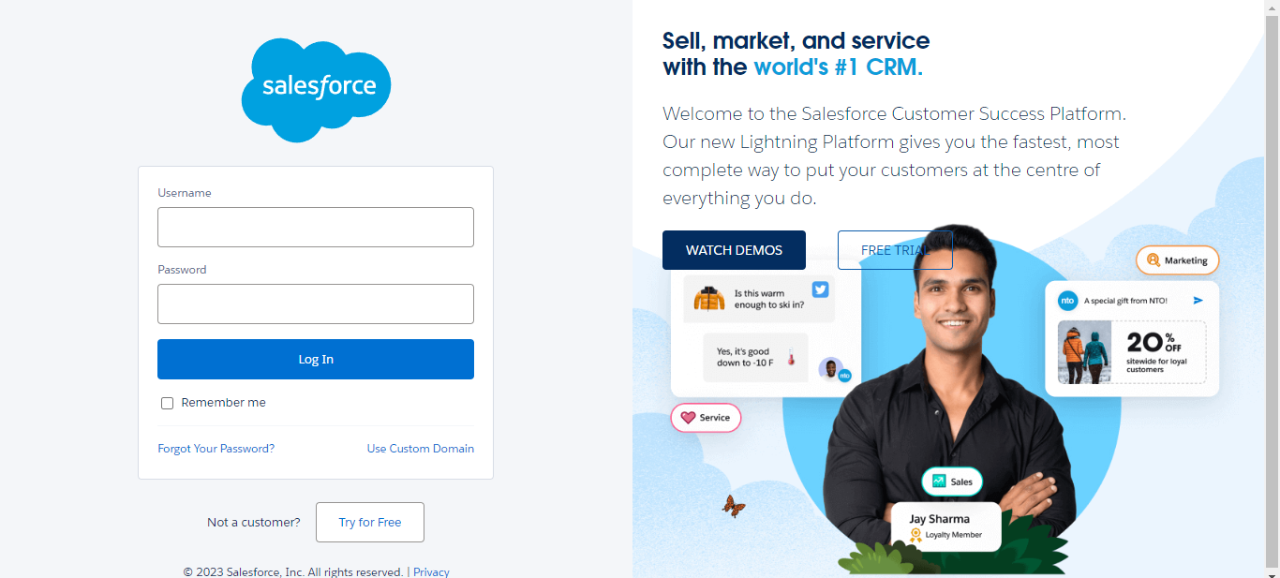

1. Creation of custom object:

Passport:

Navigate to setup to select object manager and create the object gives the detail like label name has passport and enter the plural name, record name, data type, etc., and save it.

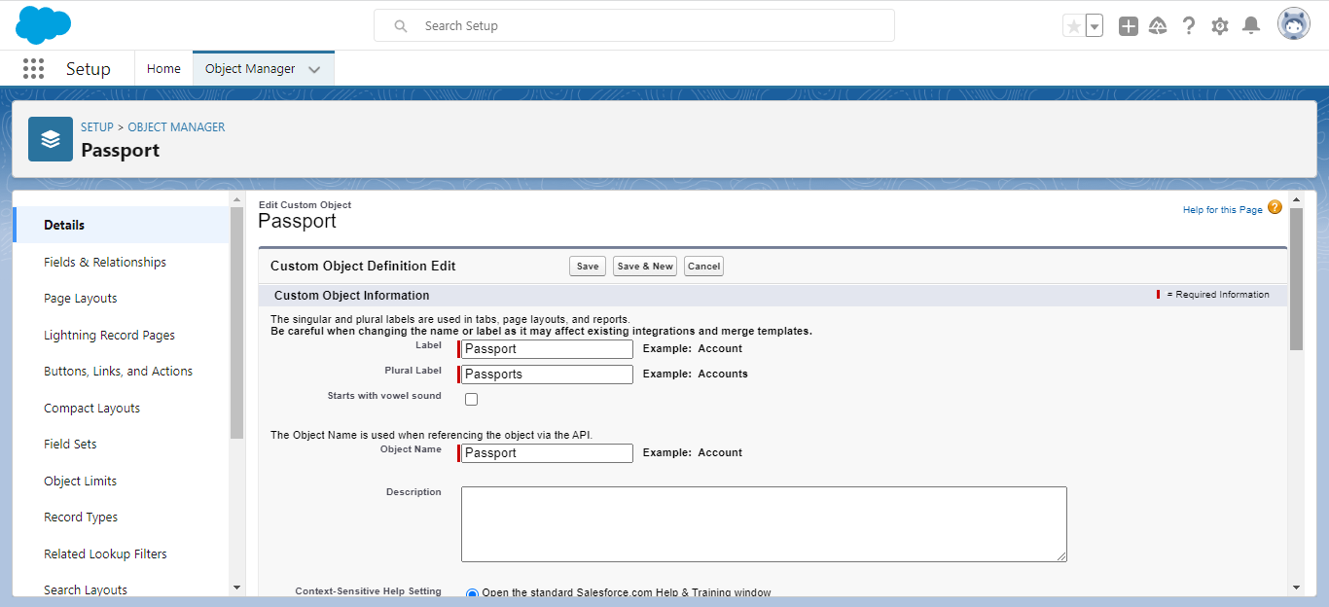

Objects involved in Book a visa are Visa slot, Payment, Reschedule/Cancel create in this type.

Visa slot:

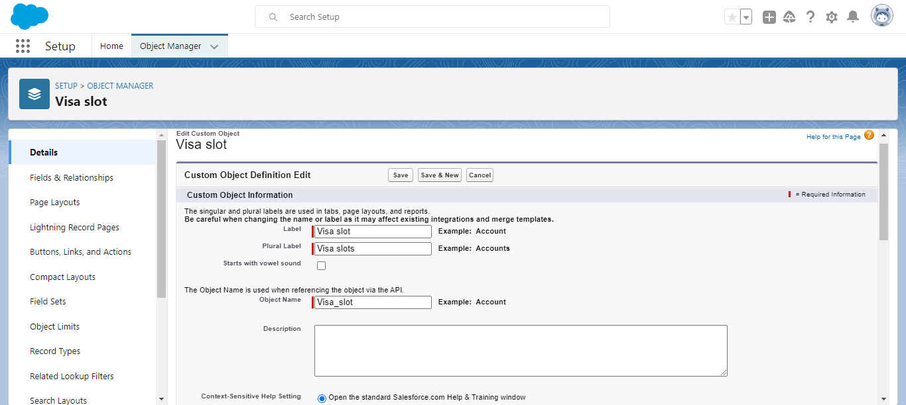

Payment:

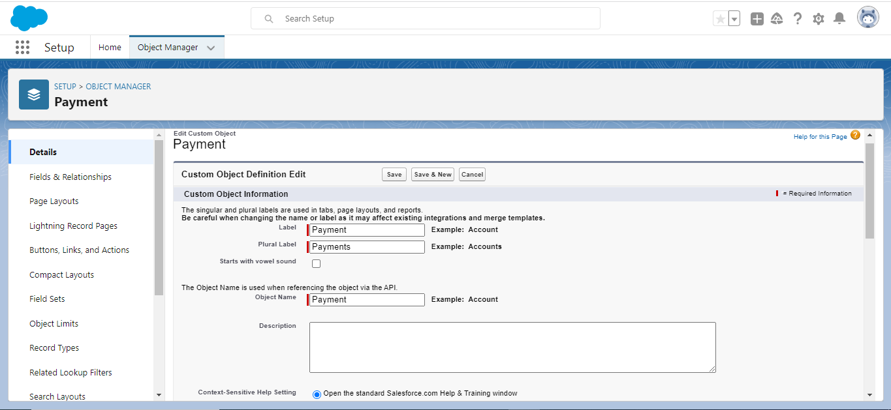

Reschedule:

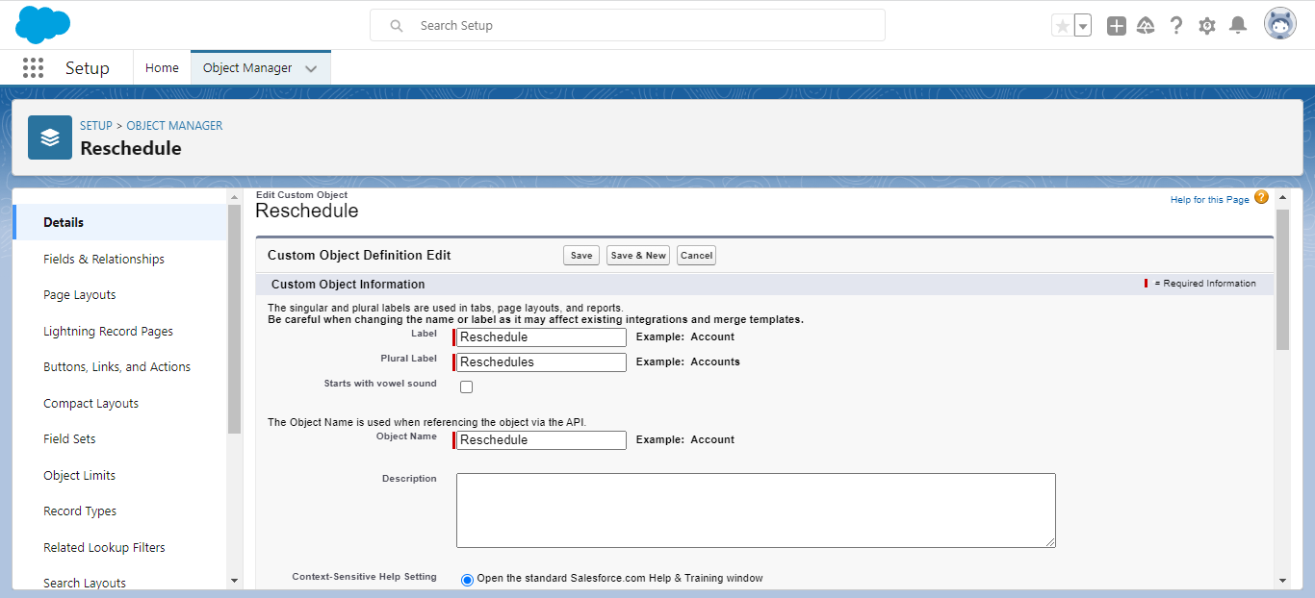

Creation of Field on Custom object: Passport

Select our Object from the selection has Passport and select option field and Relationship. Select our data type has number and go to the next page and enter the field label has Contact Number and length should be 10 at the bottom of the object you can find options like required, unique, external id select required option so that always require a value in this field in order to save. Go to next page click on visible checkbox so that it is visible to all profiles and select the next option and save it. The passport field are created like this type.

**Contact number:**

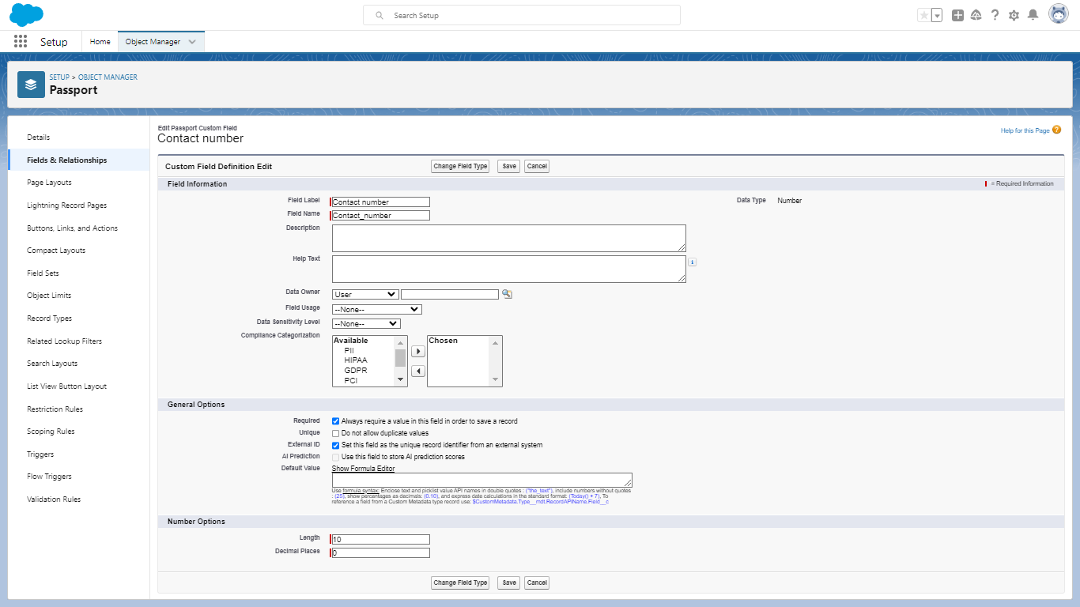

**Full Name:**

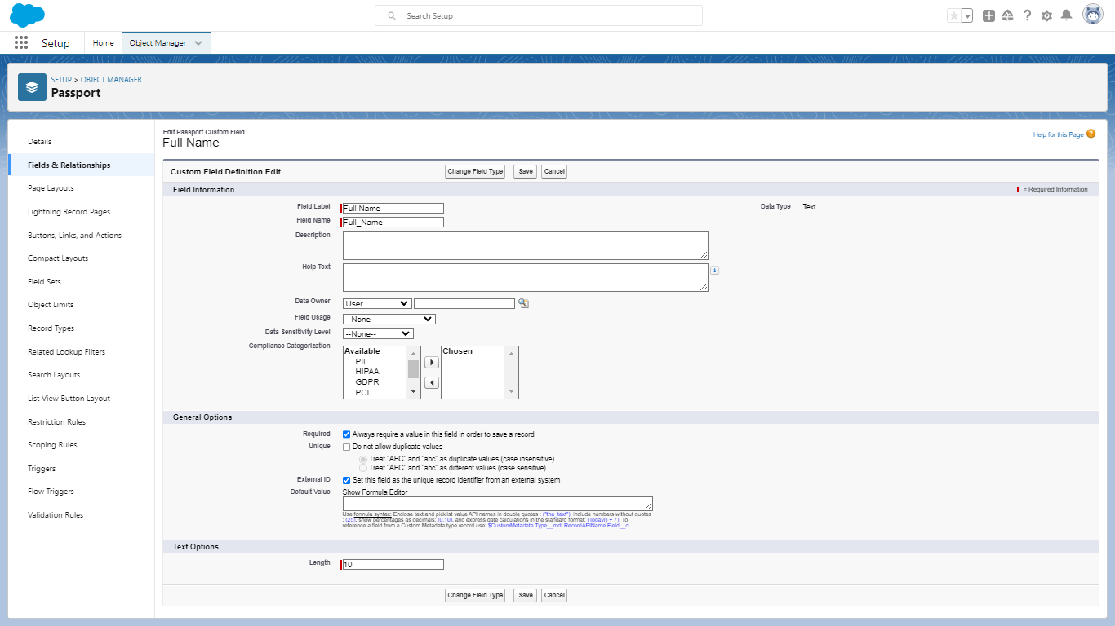

**Passport Number:**

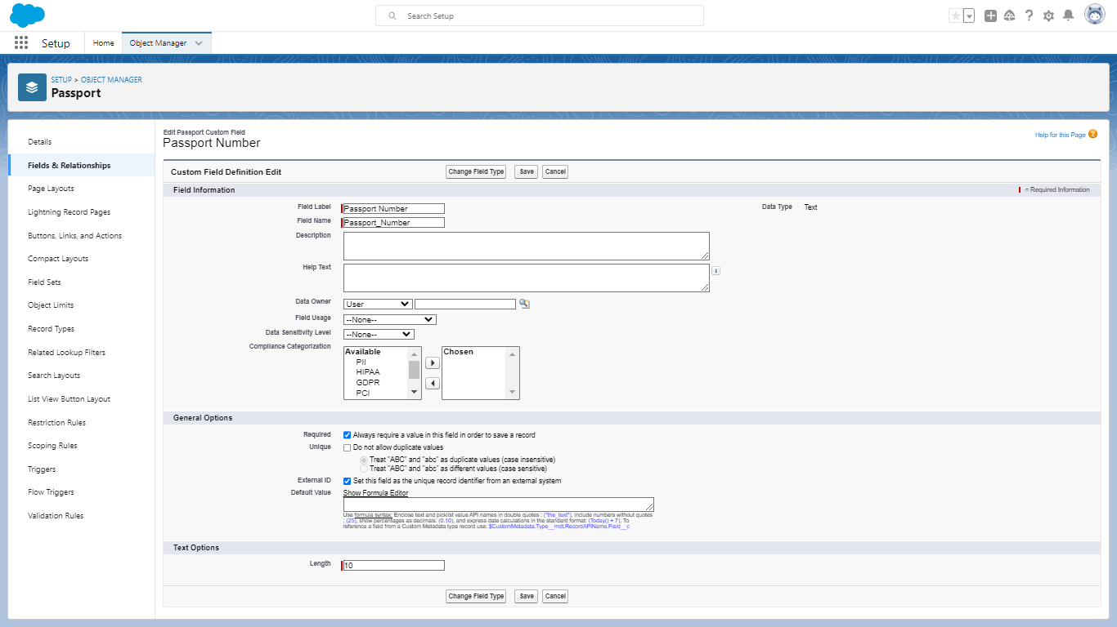

**Permanent Address:**

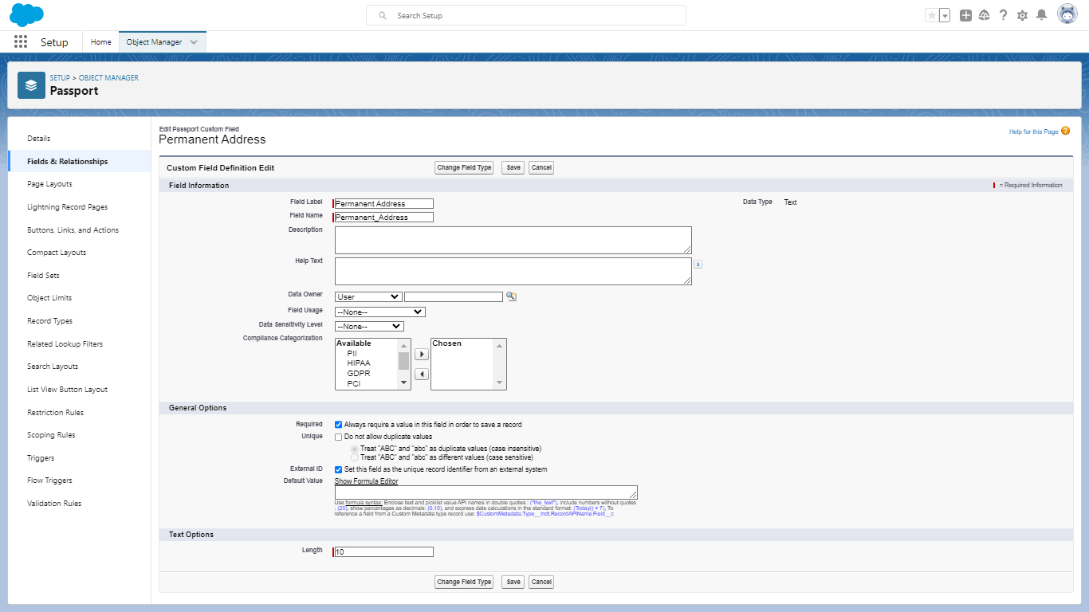

Creation of Field on Custom object: Visa slot

Select our Object from the selection has visa slot and select option field and Relationship. Select our data type has text and go to the next page and enter the field label has Location and length should be 10 at the bottom of the object you can find options like required, unique, external id select required option so that always require a value in this field in order to save. Go to next page click on visible checkbox so that it is visible to all profiles and select the next option and save it. The visa slot field are created like this type.

**Location:**

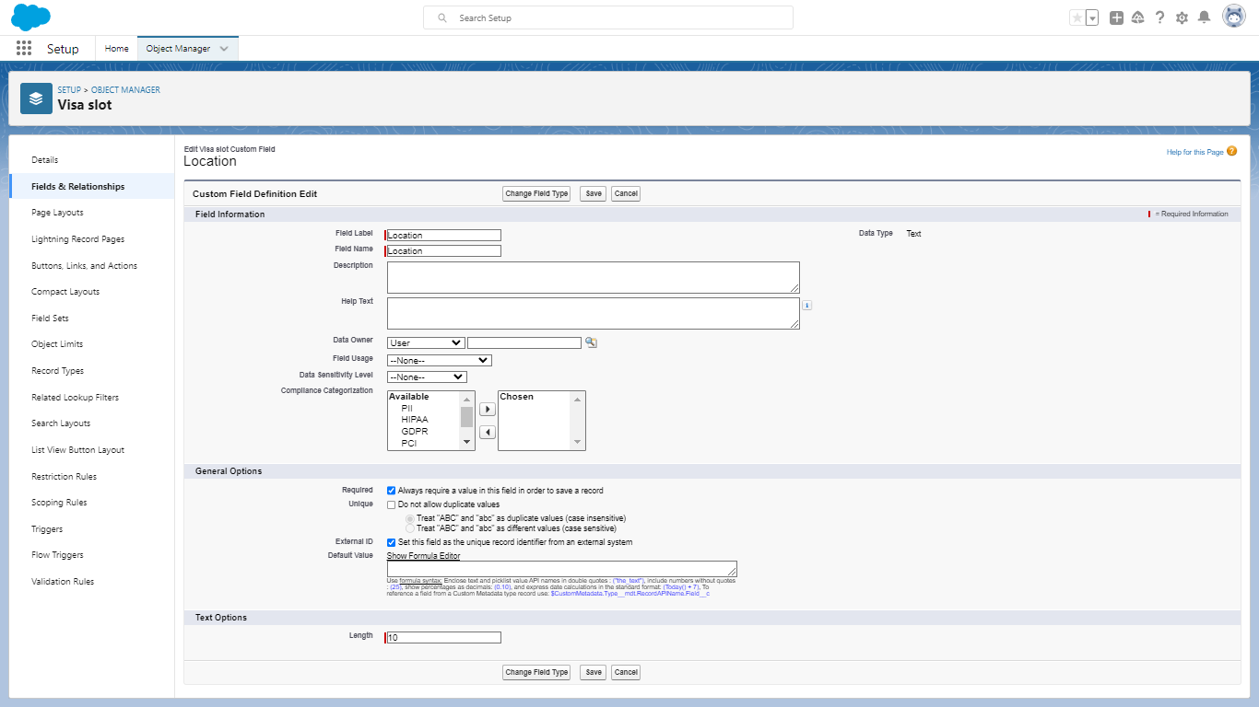

**Time:**

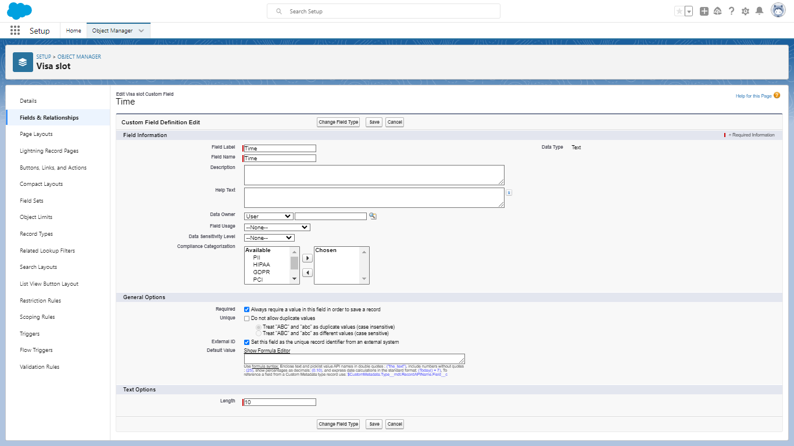

**Passport Number (Master):**

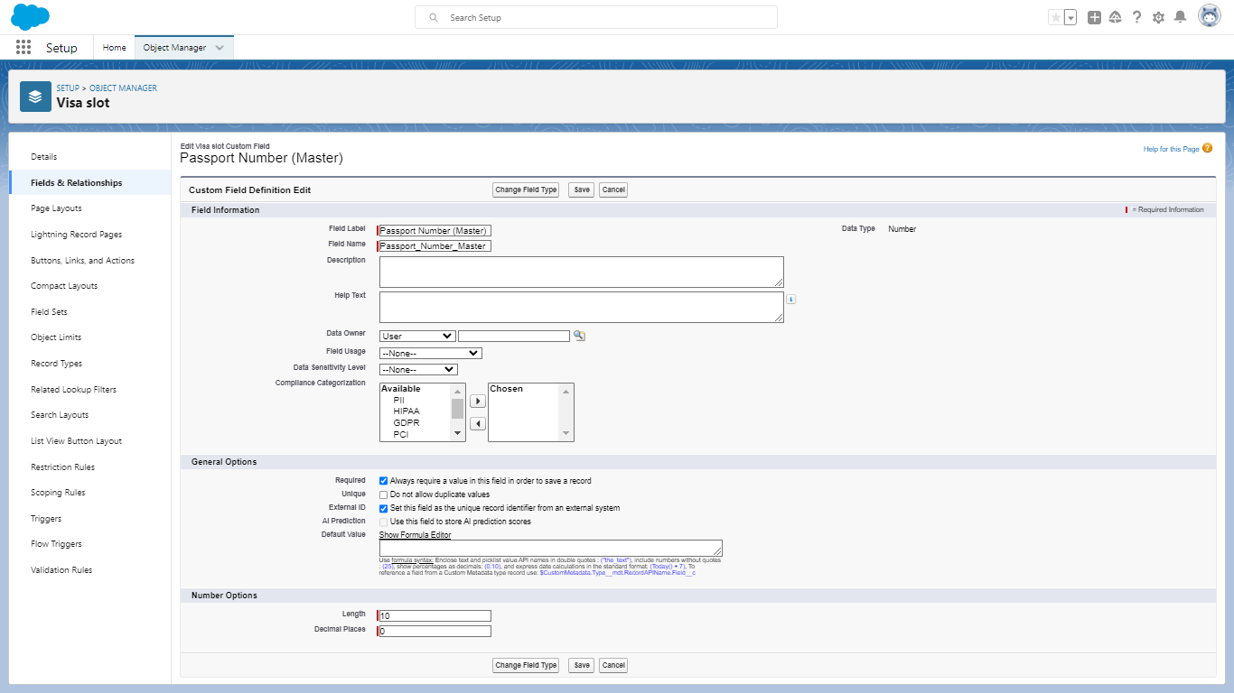

**Visa slot Number:**

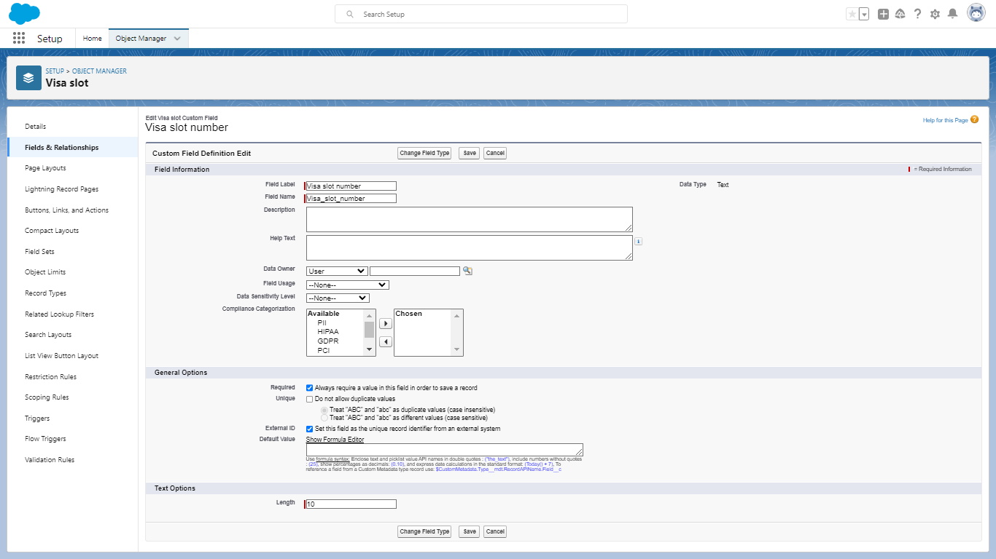

Creation of Field on Custom object: Payment

Select our Object from the selection has payment and select option field and Relationship. Select our data type has text and go to the next page and enter the field label has Payment mode and length should be 10 at the bottom of the object you can find options like required, unique, external id select required option so that always require a value in this field in order to save. Go to next page click on visible checkbox so that it is visible to all profiles and select the next option and save it. The payment field are created like this type.

**Payment mode:**

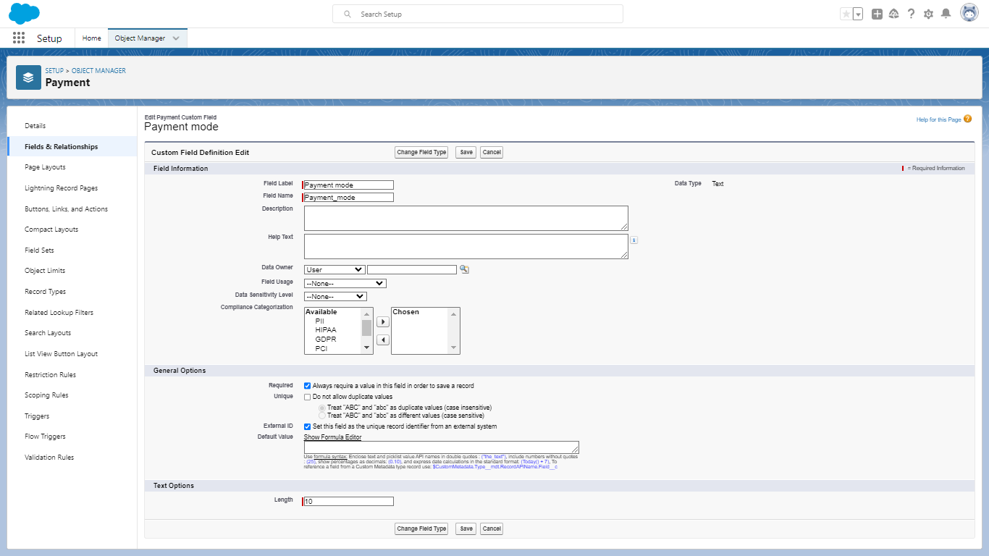

**Transaction id (Auto Number):**

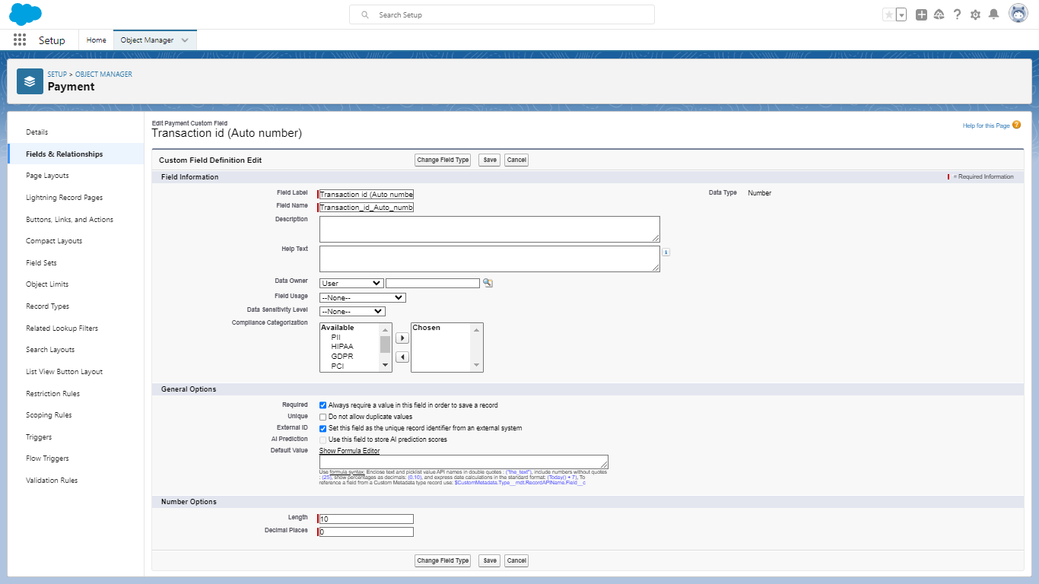

**Cancel Transaction:**

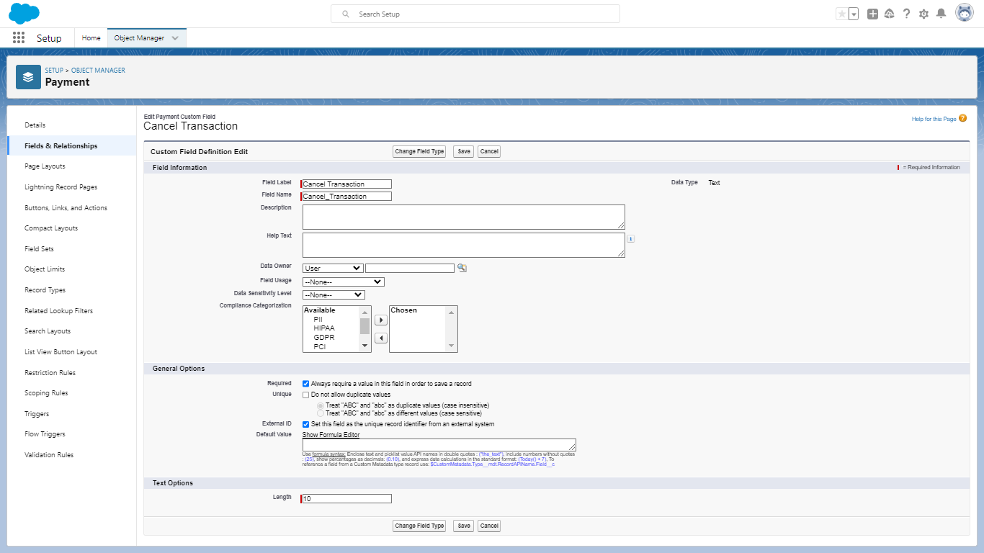

**Visa slot Number(master):**

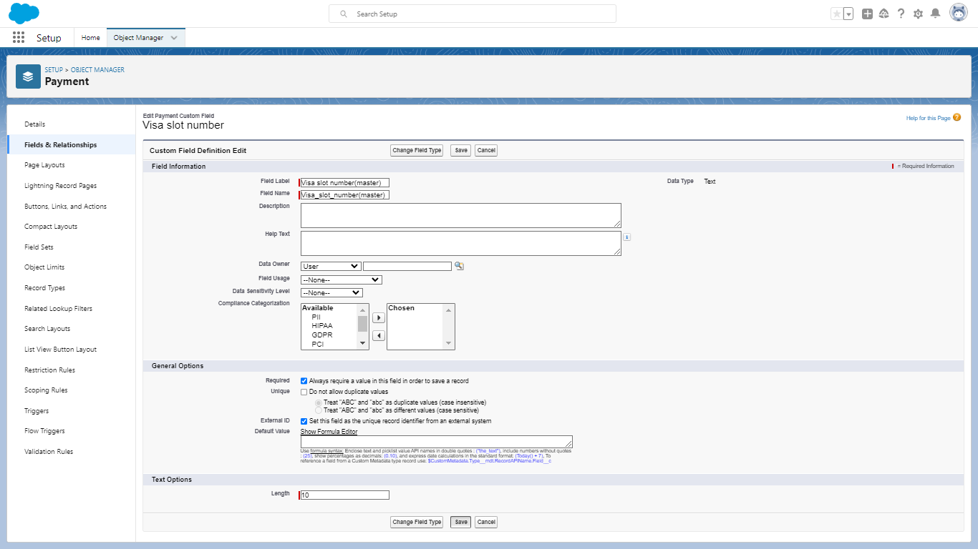

Creation of Field on Custom object: Reschedule

Select our Object from the selection has Reschedule and select option field and Relationship. Select our data type has text and go to the next page and enter the field label has Passport number(master) and length should be 10 at the bottom of the object you can find options like required, unique, external id select required option so that always require a value in this field in order to save. Go to next page click on visible checkbox so that it is visible to all profiles and select the next option and save it. The reschedule field are created like this type.

**Passport Number (Master):**

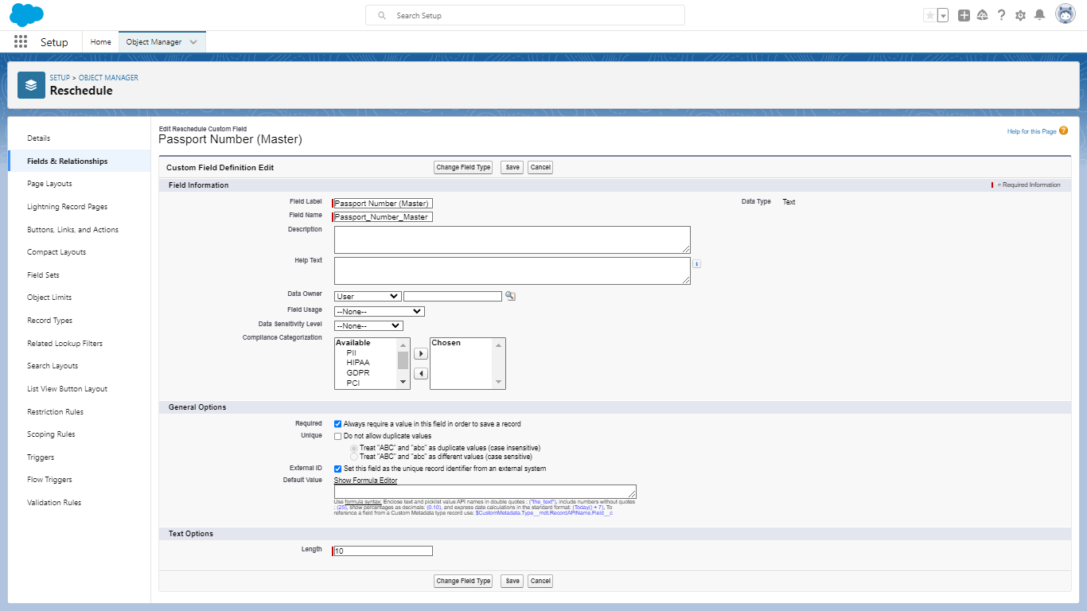

**Location:**

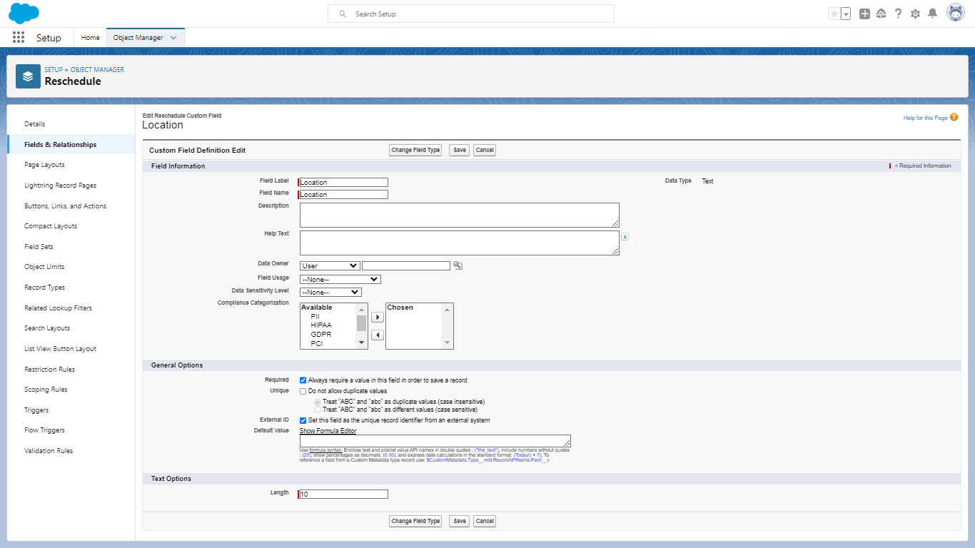

**Time:**

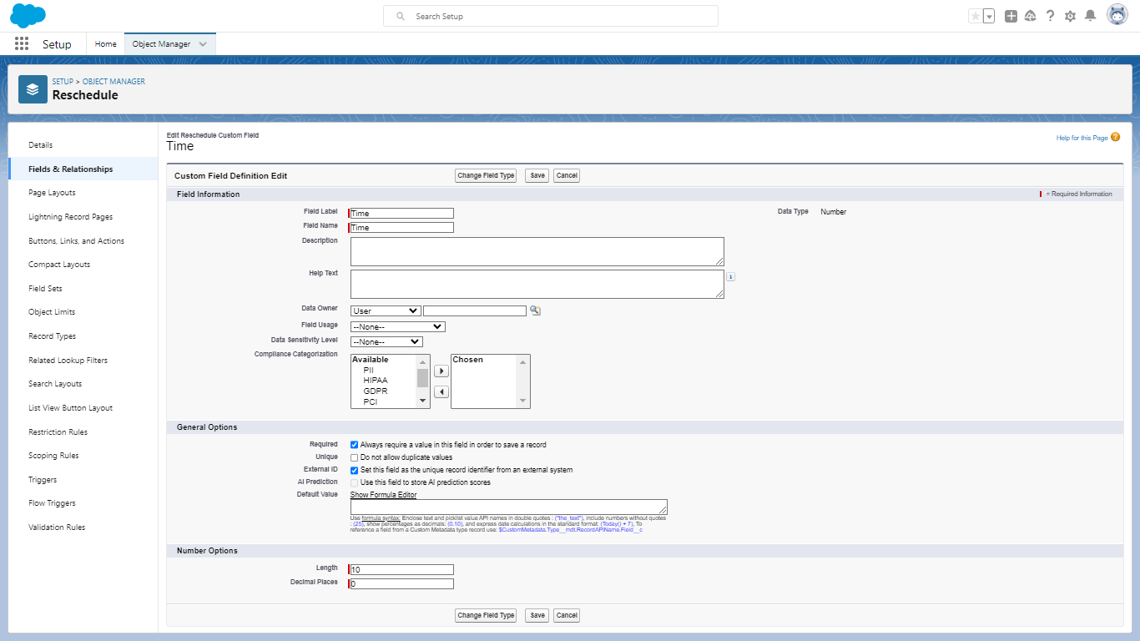

**Cancel:**

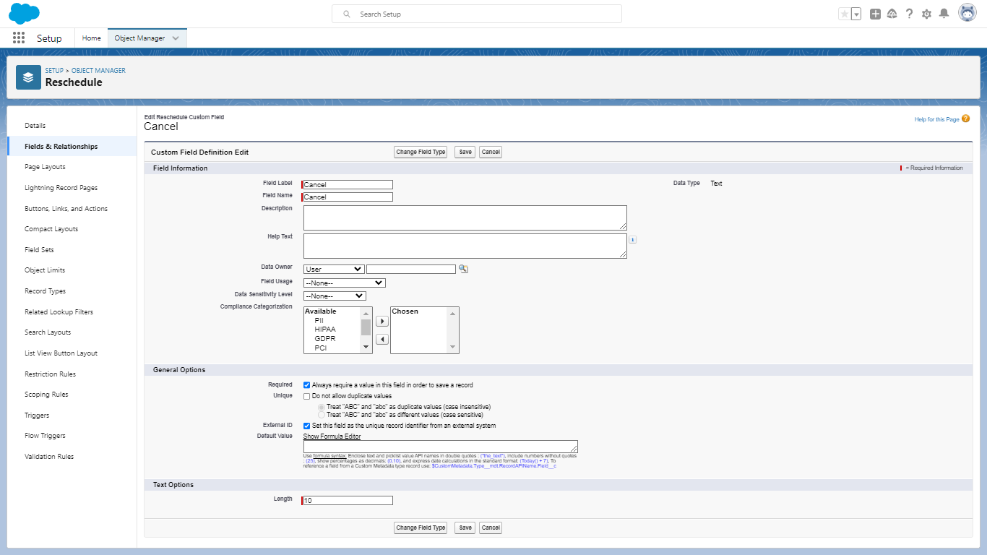

1. Creation of Relationship:

Relationship between objects

To create a Master Detail relationship between Passport and Visa. Select the object manager and select ‘visa’ object from the list and select fields and relationships and click on new. Select the data type has Master detail relationship and go to the next page and save it. To create the relationship between payment and visa slot in this type.

Master Detail Relationship between passport and visa slot:

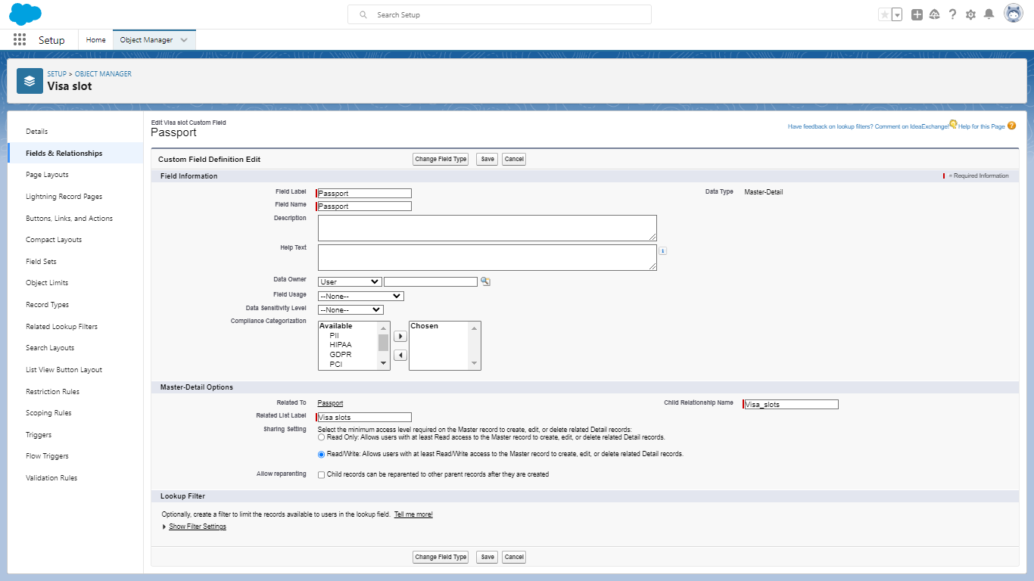

Master Detail Relationship between payment and visa slot:

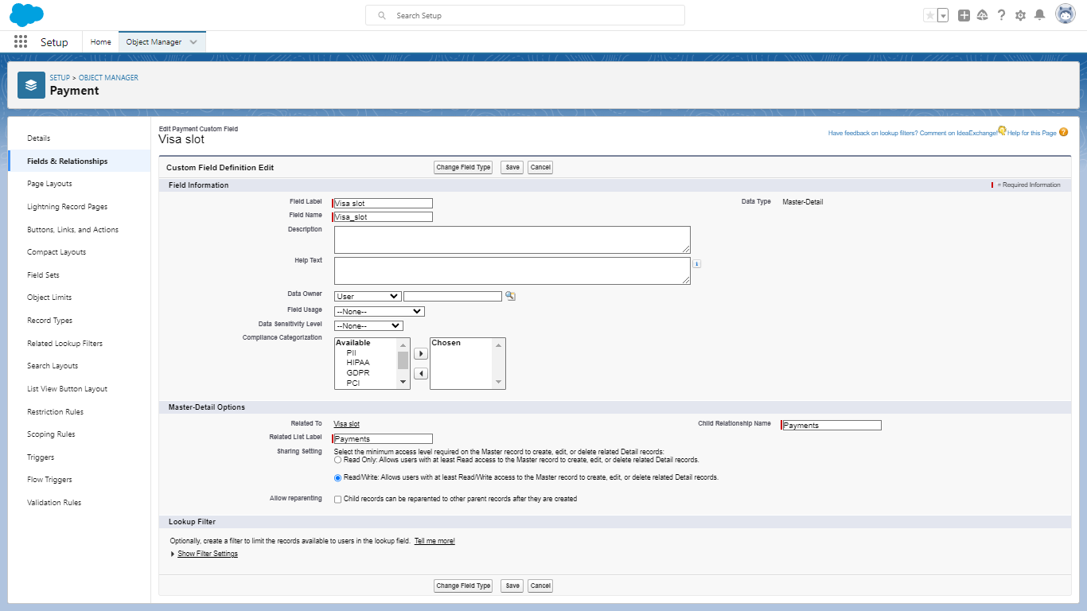

1. Creation of App:

 Navigate to setup and search for app manager. To select an option for a new lightning app. Give the app name has book my visa and upload the picture and click next. Choose the app option as navigation style- standard navigation, support from factors-desktop mobile and select next. And move the objects from available items to selected items. Passport, visa slots, payments, reschedule to selected items. And system admin profile to available items to selected items.

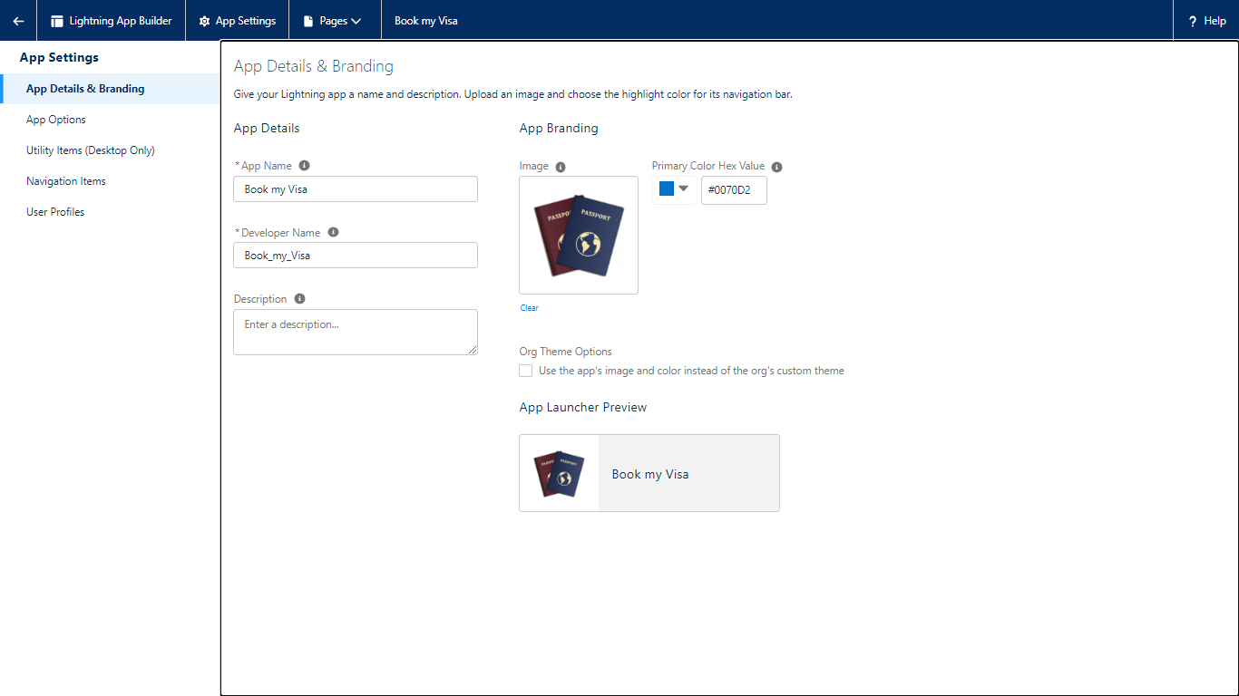

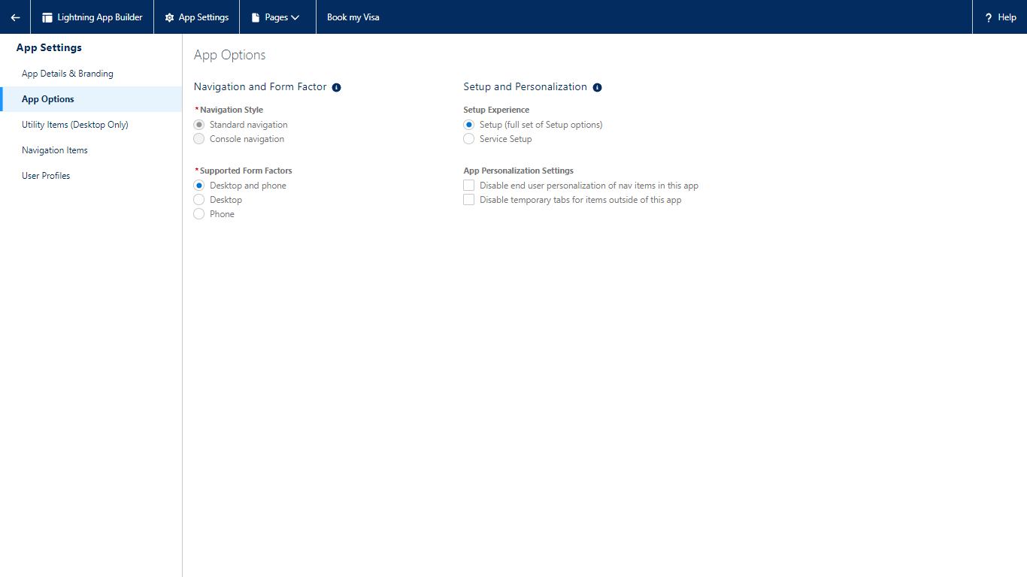

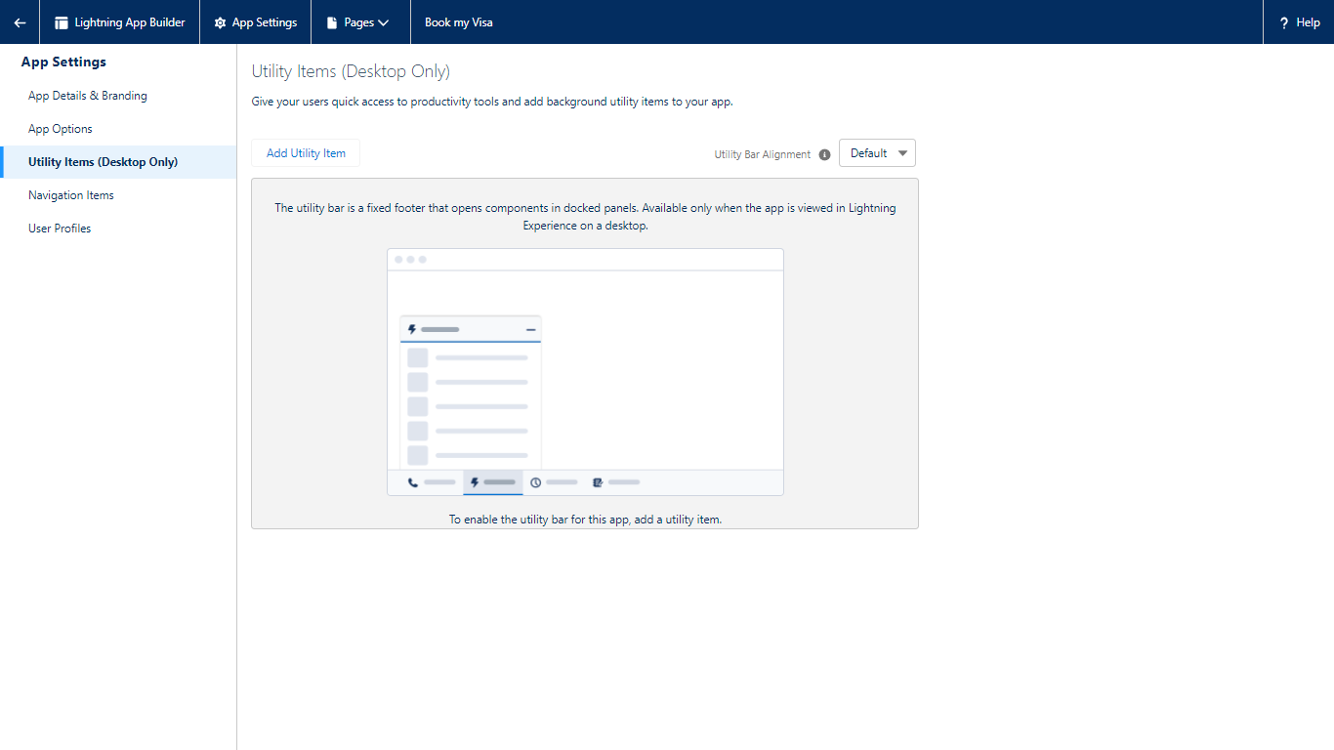

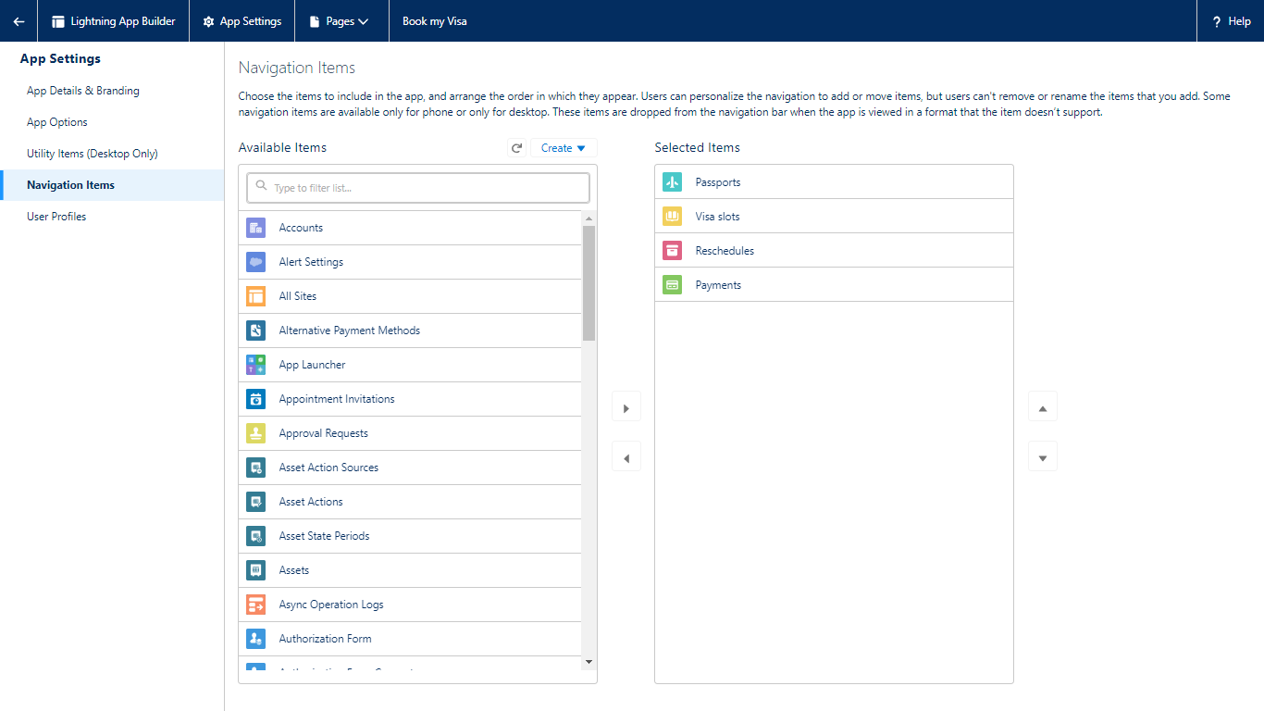

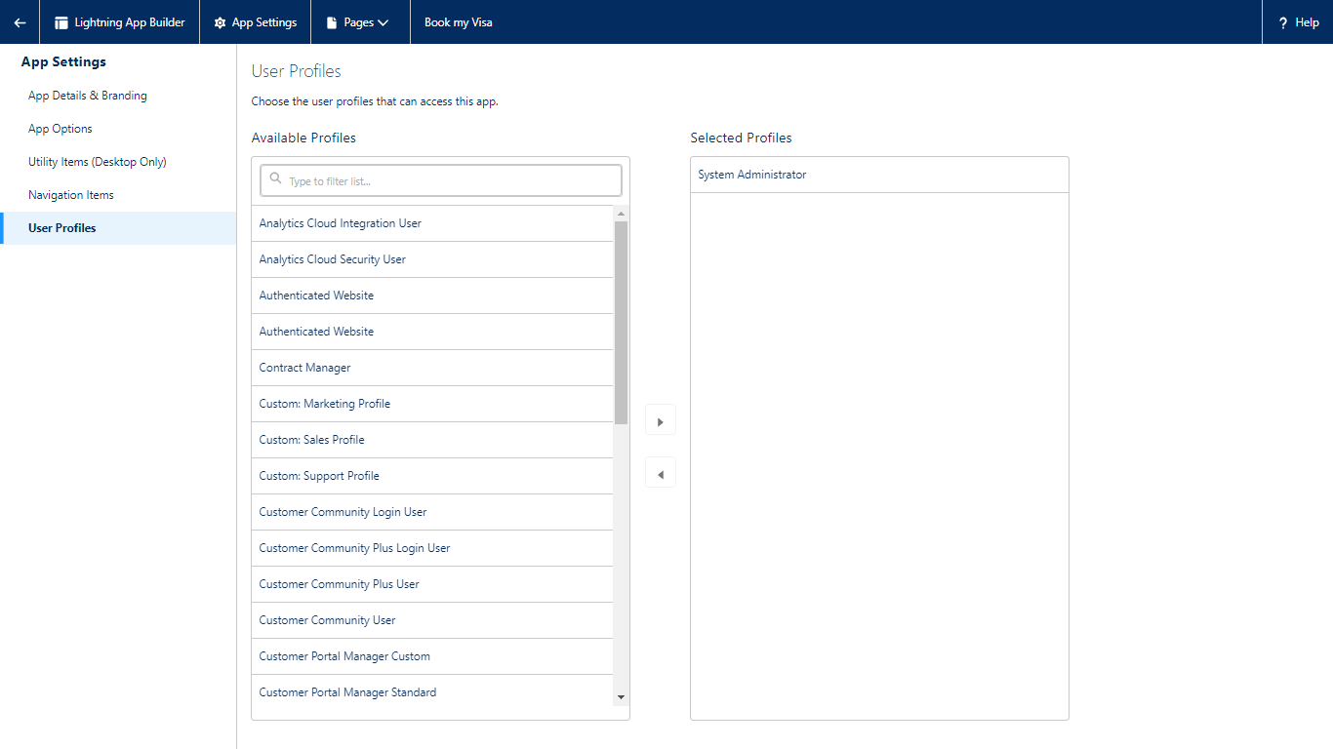

1. Creation of User:

Navigate to setup in quick find search bar, Type user in and select it and click on new user. Give the first name and last name and enter your email in the email field. Enter username; it must be unique. Select the user license of salesforce. In the profile field select standard user. At the bottom of the page check the box to generate a new password and save the page.

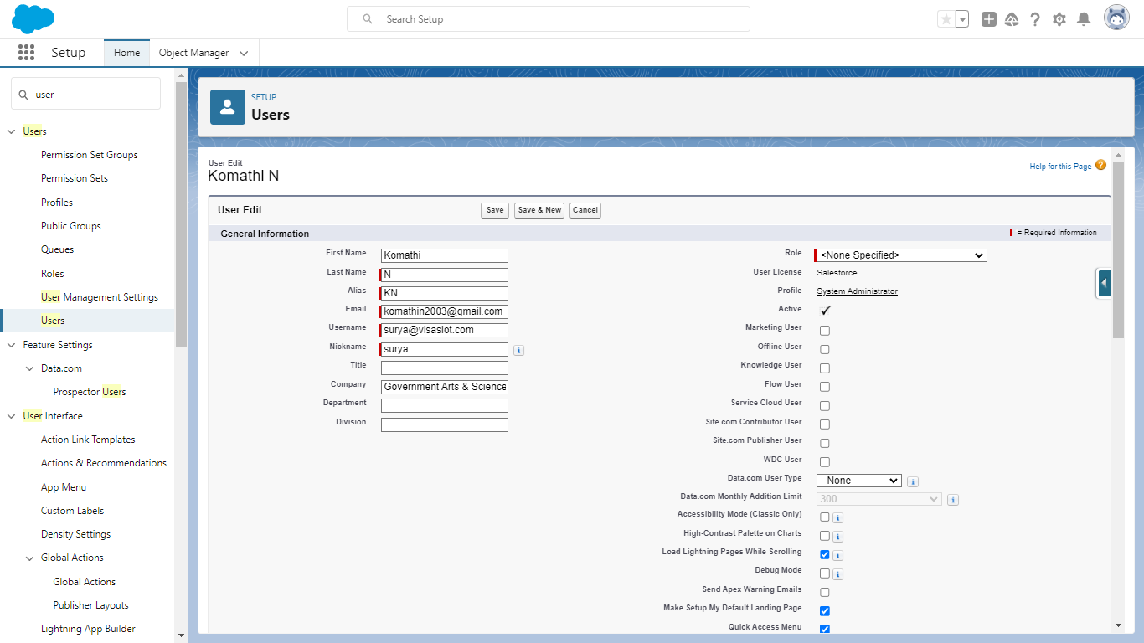

**OWD**: Organization wide default settings

This can be used to give permissions to the organization wide and it can be used for restrict the access, we can control the record level access.

Go to the setup to find out the sharing setting selected it. Edit the organization – wide Default and Select the passport and change the default external access to Public/Read/write.

1. Create a report:

Click on the app launcher and search for book a visa. Select the report and click new report, select the report type has passport with visa slot with payment and select start report. Left side of the report you can find the outline pane. In the group row select location and group column select passport; passport number to display and add the column select has visa slot number.

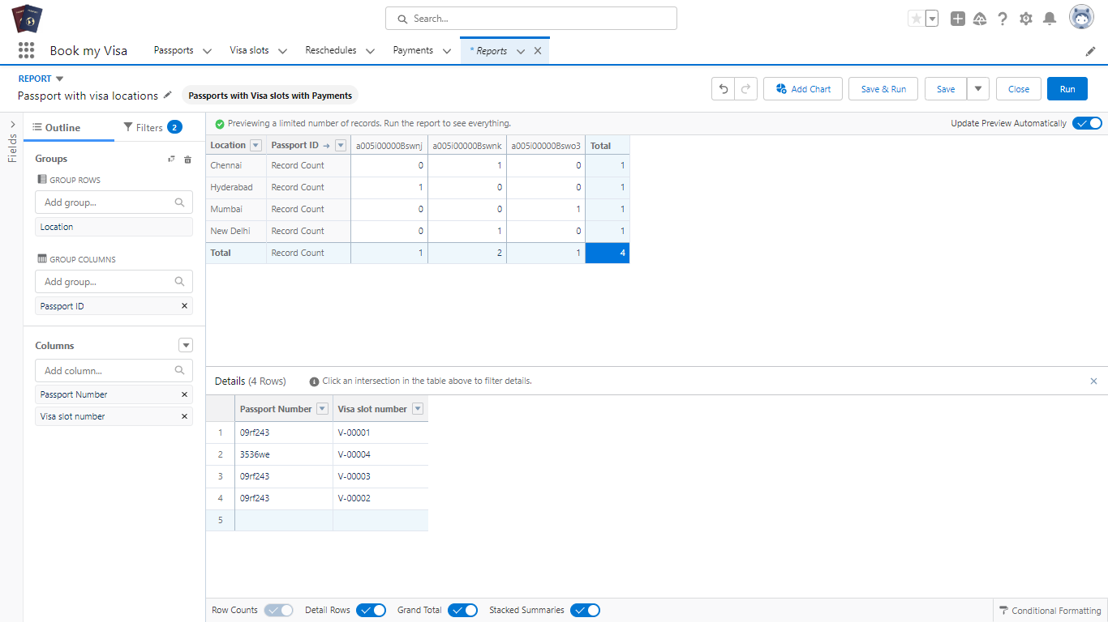

Edit the filters as show me select all passport and passport creator date select all time finally save and run it. Go to the edit option and click exports select excel sheets format and click export. We can see the detail in the excel sheets as shown.

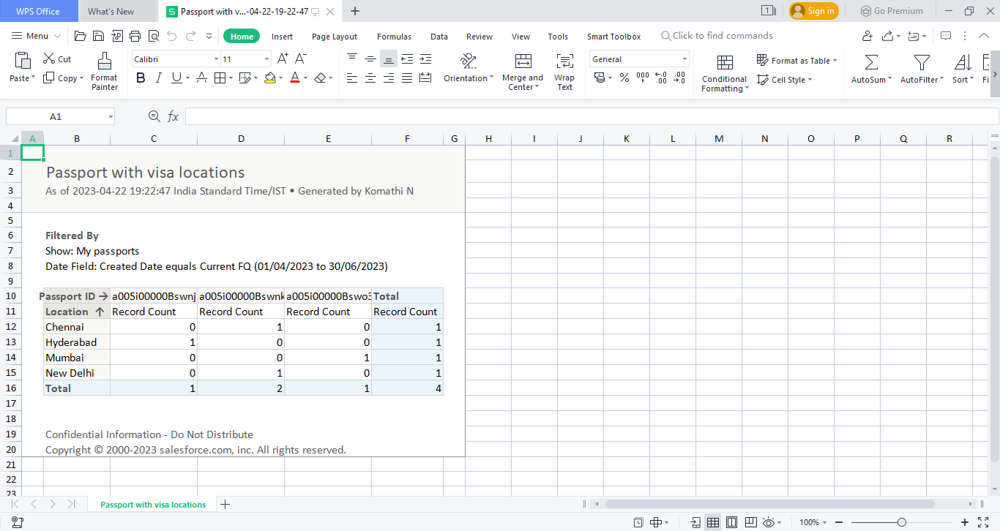

1. Create a Dashboard:

 Click on the app launcher, search for Book a visa and search for dashboards. Select the new dashboard option. Name the dashboard has a Passport with visa locations. And select create option. Now click on Add component and for report select passport with locations.

Select the donut chart as selection. Ensure the value is record count and sliced by locations. Click add and save the dashboard.

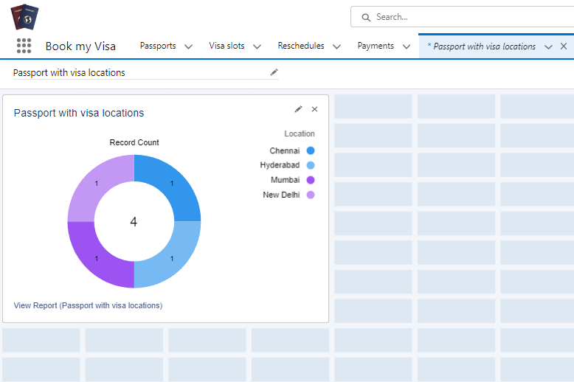

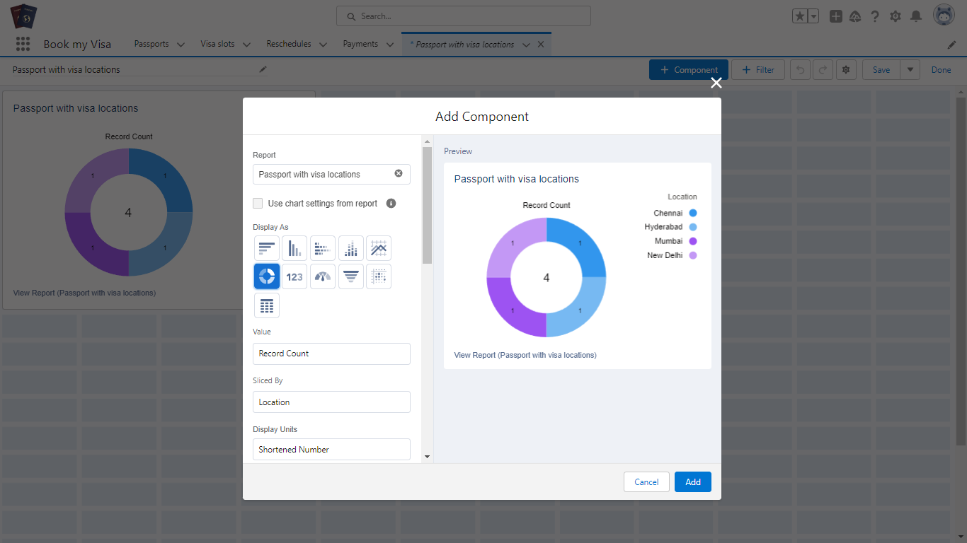

**ADVANTAGES AND DISADVANTAGES**

Advantages:

* Saving time.
* Processing is fast.
* Not much paper work.
* Easiest way.
* No wandering.

Disadvantages:

* Internet connection problem is there.
* Poor communication.
* Lack of leadership.
* Burdensome data entry.
* Poor connection leads to troubles and anxiety.
* Can be costly.

**APPLICATIONS**

This will help you to track and manage the availability of visa slot, which are appointments that are required for certain visa applications.

CRM is a well-conceived business strategy with long terms outcomes the maximize profitability, revenue and customer satisfaction by organizing around customer segment, fostering customer satisfying actions and implementing customer centric process.

CRM is a strategy employed to learn and understand customer need wants and behavior in order to develop stronger and sustained relationship with them.

**CONCLUSION**

By using the CRM application, we should track and manage the availability of visa slots easily. Booking visa slots will be in an easier way.

It is a beneficial and useful one for the customers. Save the time and often visiting trouble is not there.

**FUTURE SCOPE**

In the space of just few years, CRMs have evolved enormously. Approachable and far easier to learn, implement, and pay for, they’ve morphed from three-letter monsters into ready-set-go software for businesses of all shapes and sizes.

**APPENDIX**

**Team leader :** KOMATHI N - https://trailblazer.me/id/komathi6

**Team member:** GAYATHRI V - https://trailblazer.me/id/gayuv23

**Team member:** GOWTHAM R - https://trailblazer.me/id/gowtham17

**Team member:** KALAISELVI V - https://trailblazer.me/id/kalai20